**Microsoft Excel 365: PowerQuery and PowerPivot**

**5.2.2 PowerPivot Install**

PowerPivot is an add-in to Excel. To add the capability:

1. Open Excel
2. Go to **File** > **Options** > **Add-Ins**
3. In the **Manage** box, click **COM Add-ins**, then **Go**
4. Check the box for all Power add-ins, then click **OK**

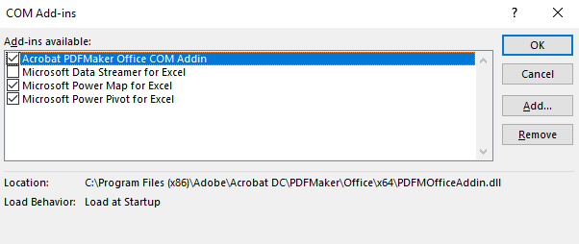

**5.3 PowerQuery**

**5.3.2 Importing Data from External Sources**

PowerQuery allows you to connect to external websites, spreadsheets, databases, and other data sources.

1. To start PowerQuery, click on the Data tab.
2. On the upper left of the screen, in the section Get & Transform, click on the down arrow next to Get Data. This is the PowerQuery section, although it is not currently labelled PowerQuery. The list of possible data sources will appear.

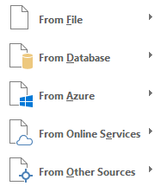

1. Put your cursor over From File, and a list of the options will appear.

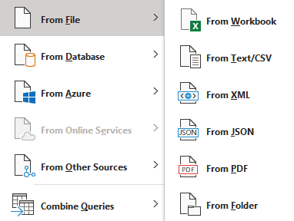

1. Next, put the cursor over From Database.

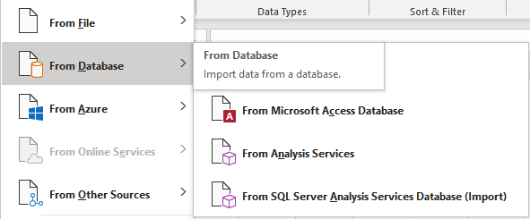

1. Now try From Azure.

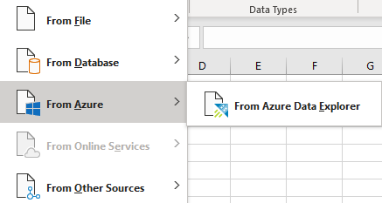

1. Finally, click on From Other Sources.

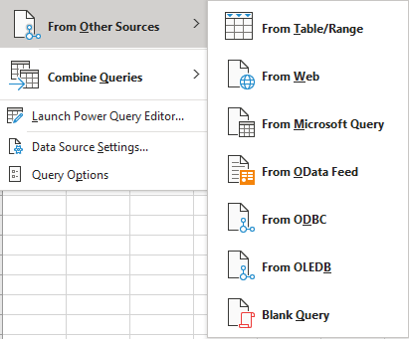

1. Let’s now connect to our data. Click Get Data, From Database, From Microsoft Access Database.

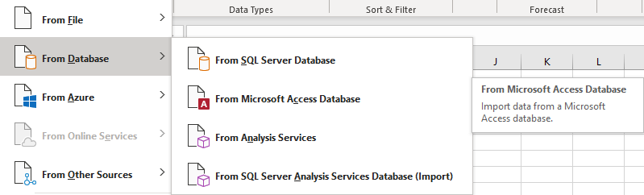

1. Find the downloaded file Orders.accdb. Click on the file name, then Import.

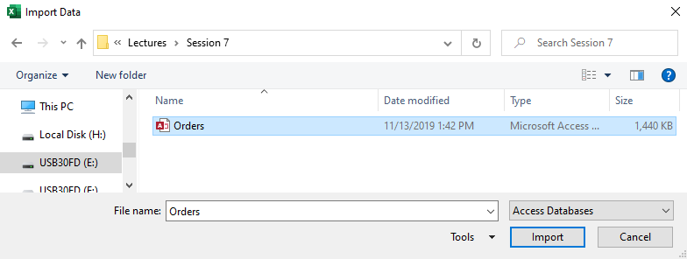

1. To connect to all tables, first check the box Select multiple items.

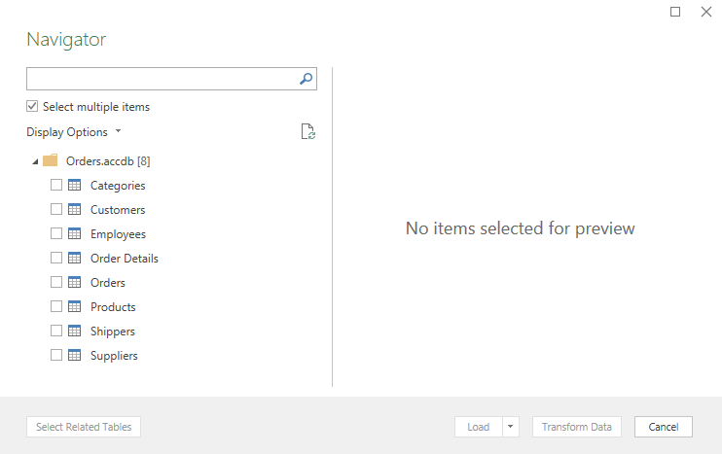

1. Next, check the box in front of each table name, then click Load.

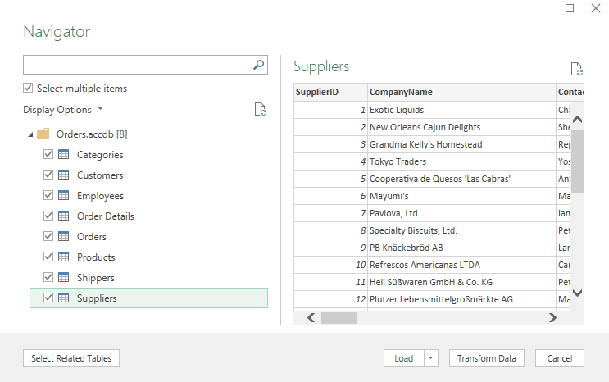

1. All table connections via Power Query will be listed on the right.

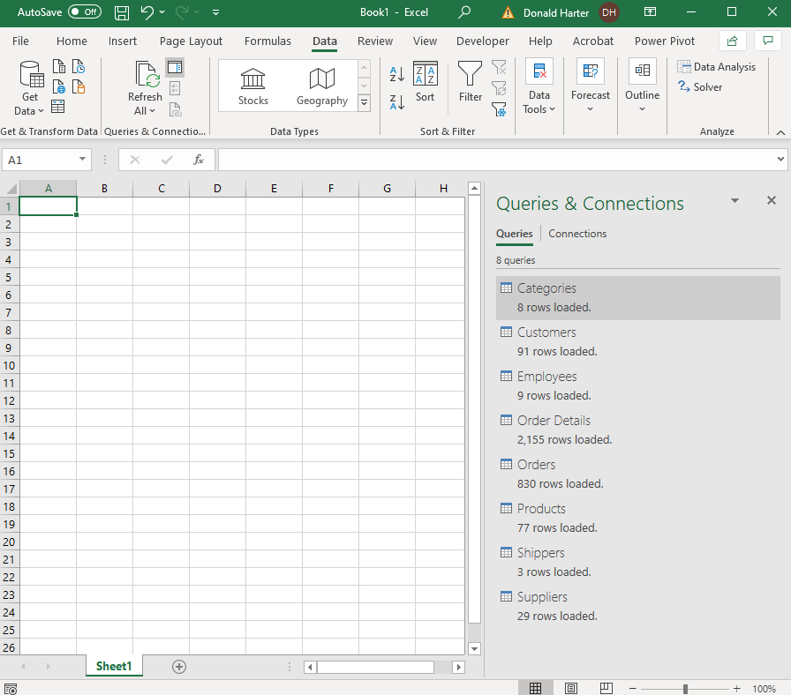

1. Save your PowerQuery worksheet as clicking on File, Save As, PowerQuery (you can name it anything that you want).

**5.3.3 Relationships**

1. Recall the relationships that we had in Access with these tables.

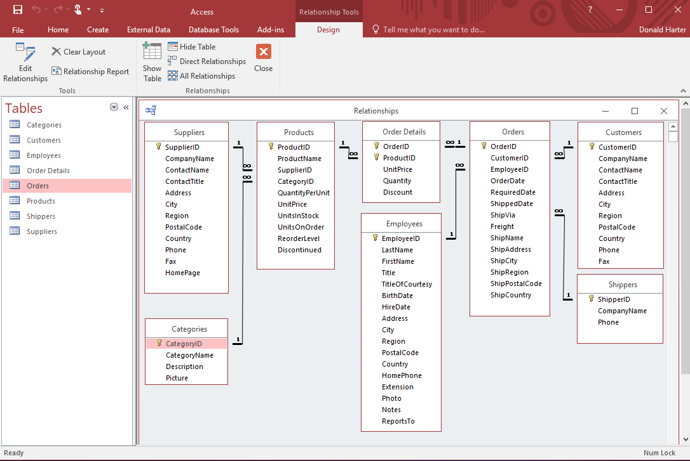

1. Click on the Data tab, in the Data Tools section click on Relationships. The Manage Relationships screen will appear. Check that the relationships match the diagram above.
2. Click close when you have confirmed that all relationships are there.

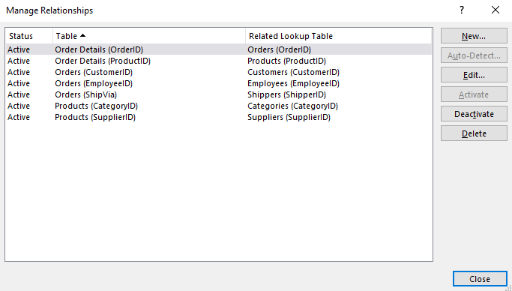

1. Click on PowerPivot.

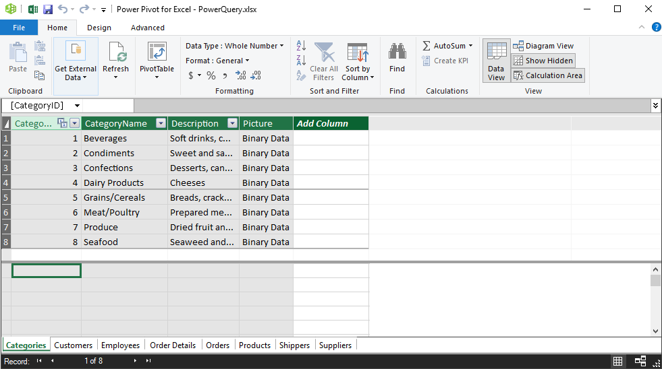

1. Now click on Diagram View (upper right corner of screen); this shows the relationship diagram for our two tables.

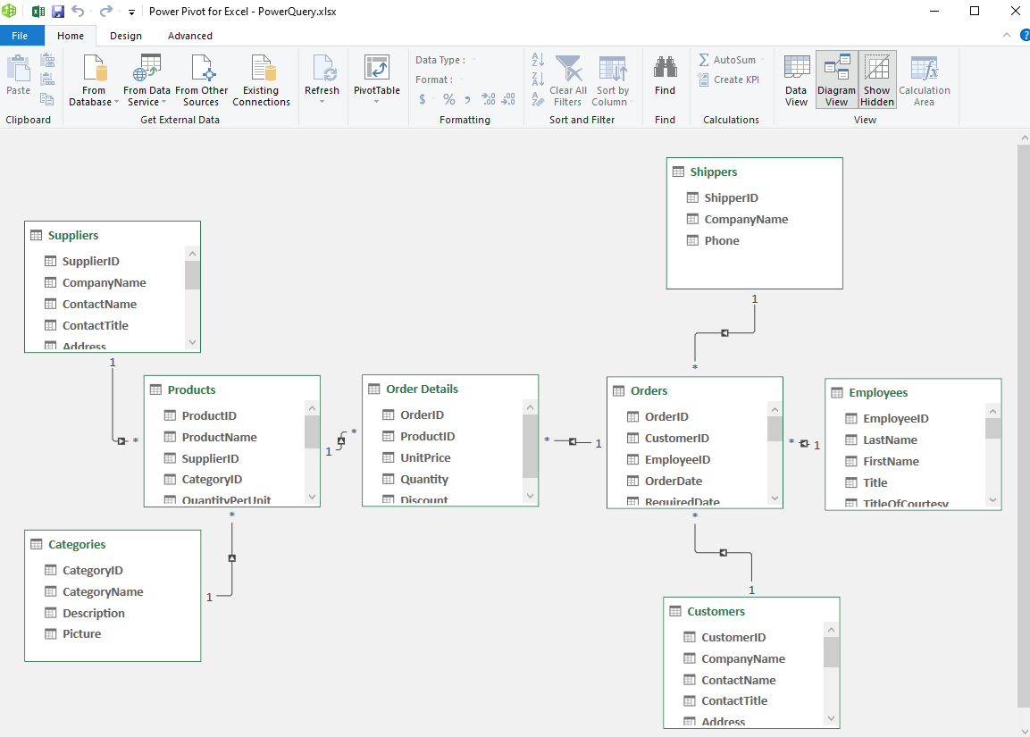

**5.3.4 Generating PowerPivot Tables**

1. At the top of the diagram view of the data model, click on Pivot Table, then Pivot Table, then on the screen below, click OK.

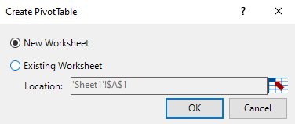

1. You will see a Pivot Table, with the data tables to the right.

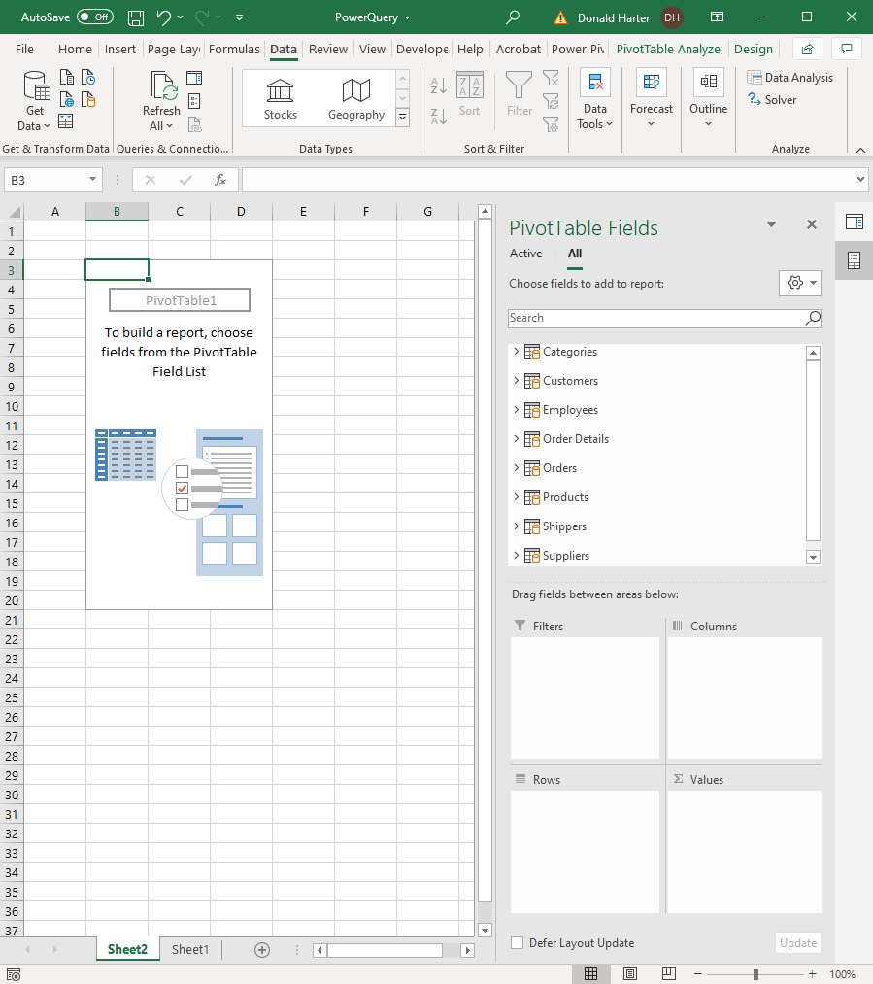

1. Next, create a pivot table using Company Name, Product Name, Units in Stock for Values.
2. Click on the arrow to the left of Suppliers, then drag CompanyName to Rows.
3. Click on the arrow to the left of Products, then click ProductName to Rows, but below CompanyName.
4. Drag Units in Stock in Products to Values.

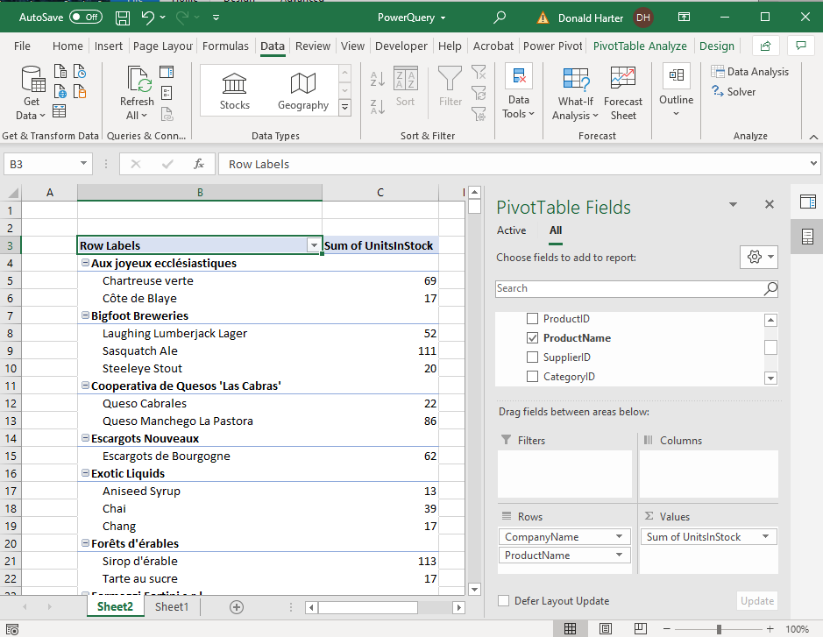

1. Note the Refresh option in the upper left. This retrieves a new copy of the data.

**5.4.2 PowerPivot Importing Demo**

We want to launch PowerPivot and import data from other sources.

1. Close the previous spreadsheet and open a new blank spreadsheet in Excel.
2. Click on the PowerPivot tab at the top of the screen.

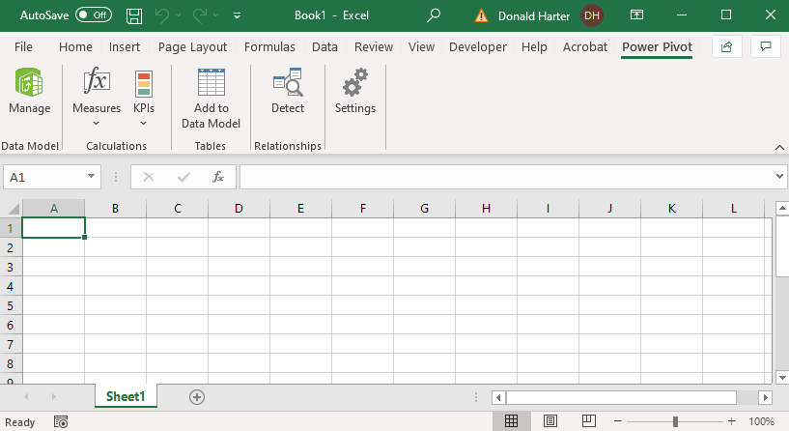

1. Click on Manage in the upper left corner.

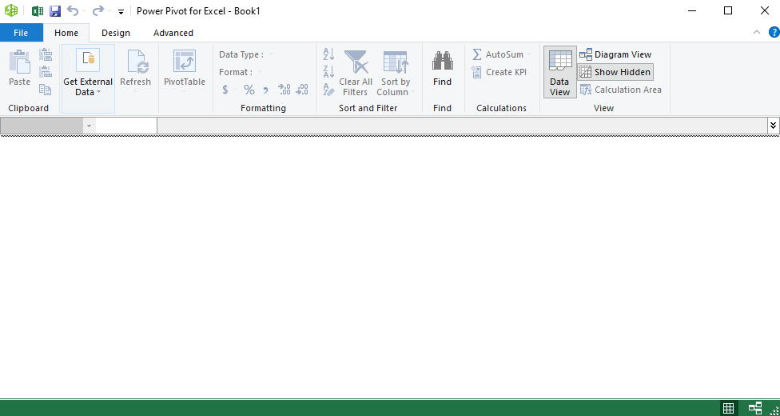

1. In the Get External Data section, click on the drop-down arrow From Database.

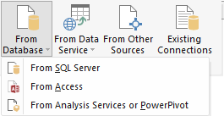

1. Next, click on the drop-down arrow From Data Service.

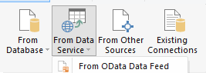

1. Finally, click on From Other Sources. Scroll down. This list is mostly databases and text feeds. PowerPivot does not include Sharepoint, or the other types of data sources.

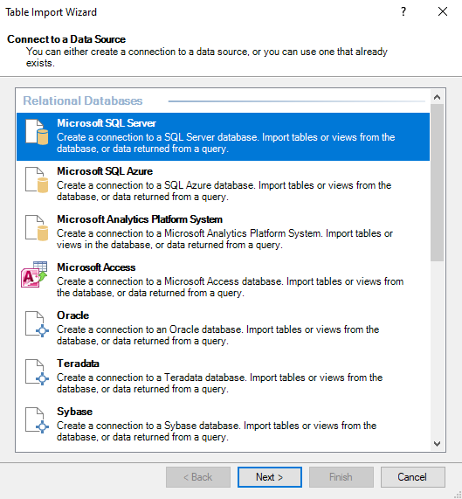

1. Click on From Database, then From Access.
2. Click on Browse, and find the Orders database; click Open.

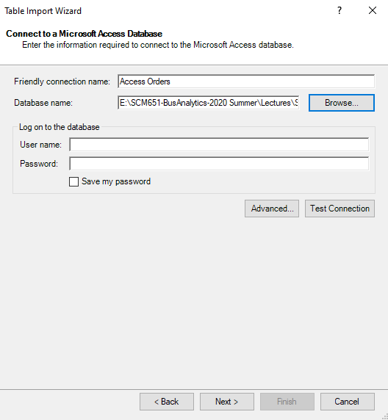

1. Select the default “Select from a list of tables,” then click Next.

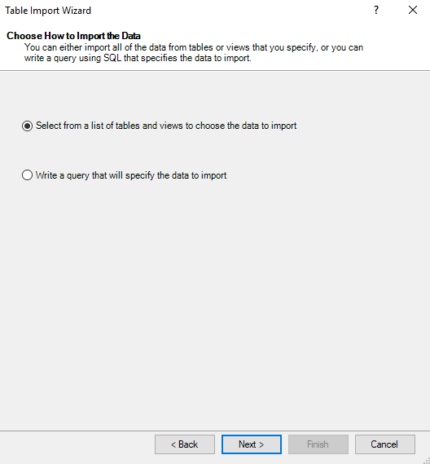

1. Check the box to the left of Source Table to automatically check Categories through Suppliers, then Finish.

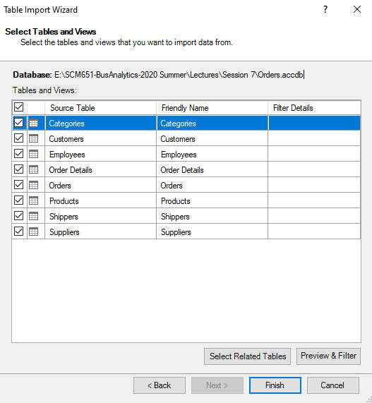

1. The completed import will list the tables and number of rows transferred; click Close.

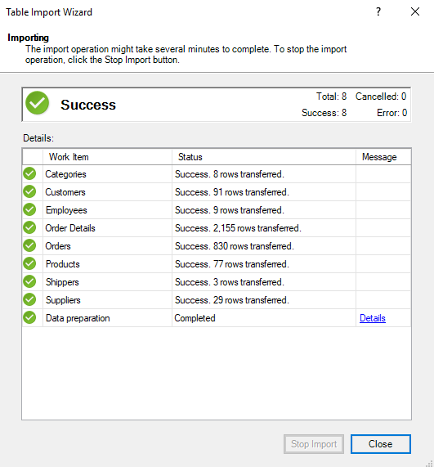

1. The data grid should appear. The tabs at the bottom include all tables.

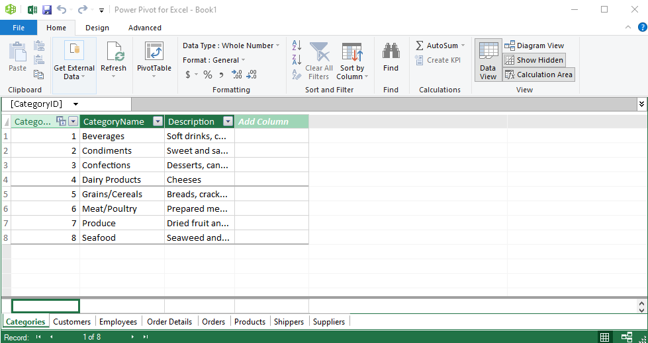

**5.5.2 PowerPivot Relationships Demo**

In Microsoft Access, we were able to establish relationships between tables. We can create similar relationships in Excel PowerPivot.

1. In the lower right corner of the Data Grid, click on the diagram view. There is also a Diagram View option in the upper right corner.
2. Notice that there is a scroll bar; you can scroll to see all the tables.

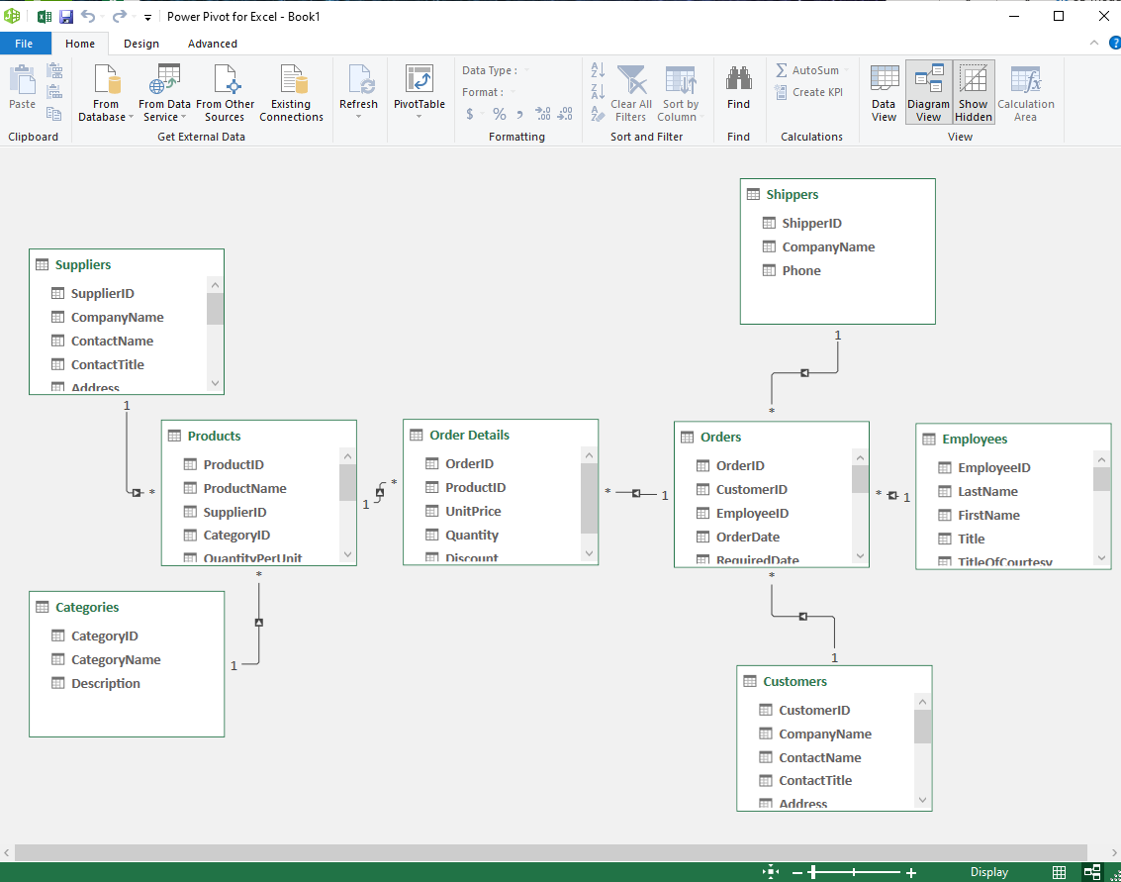

1. If a relationship does not exist, and you need to create it, simply click on the field in one table and drag to the corresponding field in another table.
2. When you are done, click on any relationship. It will show the two tables connected and the field names used for the relationship.

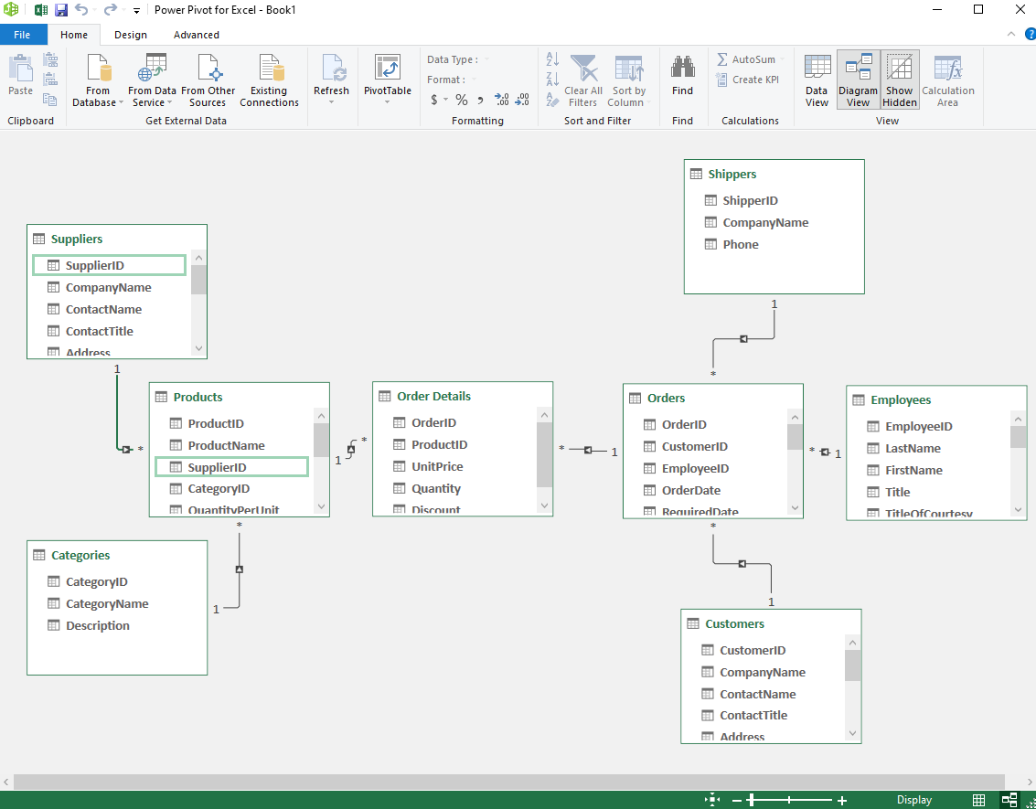

1. Save your work by clicking on File, Save As, and saving.
2. In the upper right of the screen, switch back to the Data View.
3. If you close this view, you can always come back by clicking Manage.

**5.6.2 PowerPivot Tables Properties and Filters**

**Table Properties**

Table properties presents additional information on the source of your data, data display, and filters.

1. In PowerPivot, click on the Design tab in the upper left corner.
2. Click on the title of the Suppliers table (it should highlight the table).
3. Click on Table Properties at the top of the screen.
4. Notice that the Connection Name identifies where the data originated.

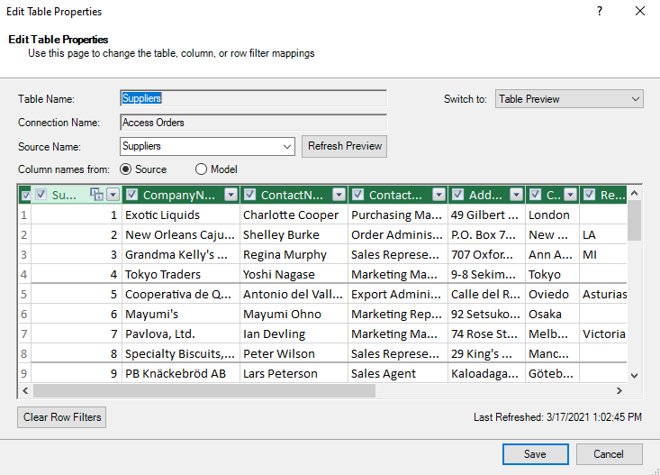

**Table Filters**

Filters are also possible in this view.

1. Click on the down arrow for Company Name.
2. Click on the box before (Select All) to uncheck the box.
3. Check the box for Bigfoot Breweries, then OK.

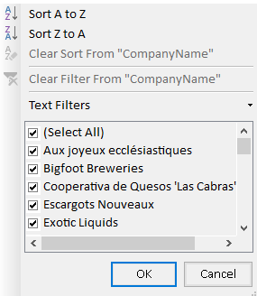

1. You should see the following filtered data.

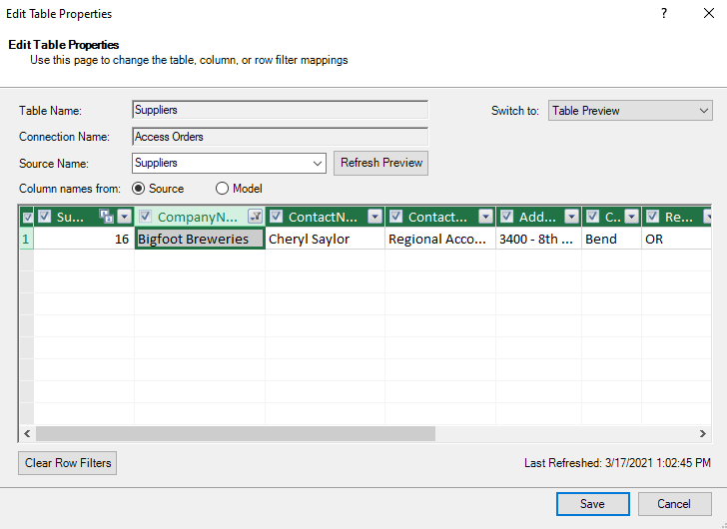

1. In the upper right of the view, click on the “Switch to:” drop down menu and change from Table Preview to Query Editor. It now displays the SQL to implement this filter.

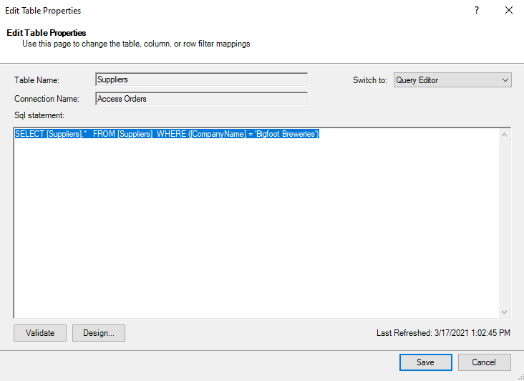

1. Change back Switch to: Table Preview, then change the filter to Select All. Cancel.

**5.7.1 Refreshing Data**

In the earlier description of Table Properties, we saw that there was an active connection to our original database. What happens if your database is updated? You do not need to re-import the data, just use the refresh option. (Refresh works in both Power Query and Power Pivot.)

1. In the PowerPivot screen, click on the Home tab in the upper left corner.
2. At the top of the screen is Refresh button. Hover over the button and it says: “Refresh the data that was imported from external data sources.”
3. Click on the Suppliers table to highlight it.
4. Click on the down arrow below the refresh button.



1. Click on Refresh. PowerPivot goes to the Access database, retrieves the Suppliers data, and updates your table.

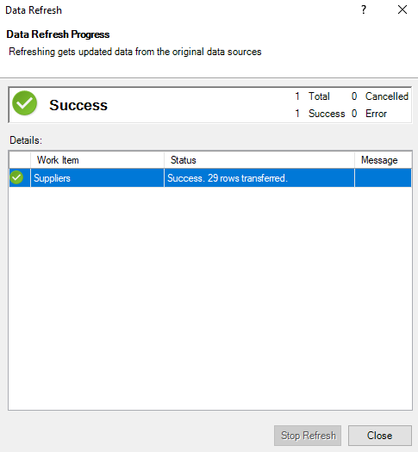

1. Similarly, try Refresh All.

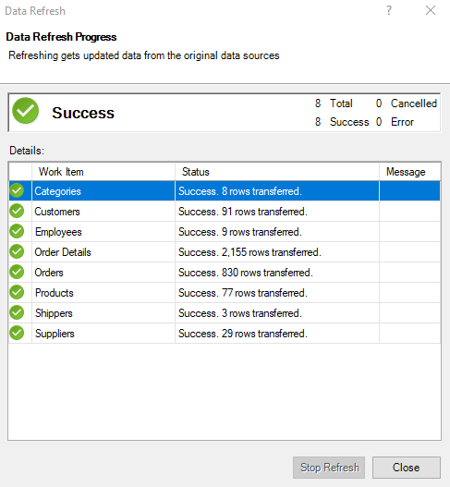

**5.8.2 Creating Pivot Tables with PowerPivot**

Now create Pivot Tables, incorporating data across multiple tables.

1. In PowerPivot, click on the Home tab in the upper left corner.
2. At the top of the screen, click on the drop-down arrow below PivotTable and select Pivot Table.

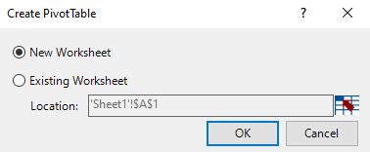

1. Select New Worksheet, then OK.

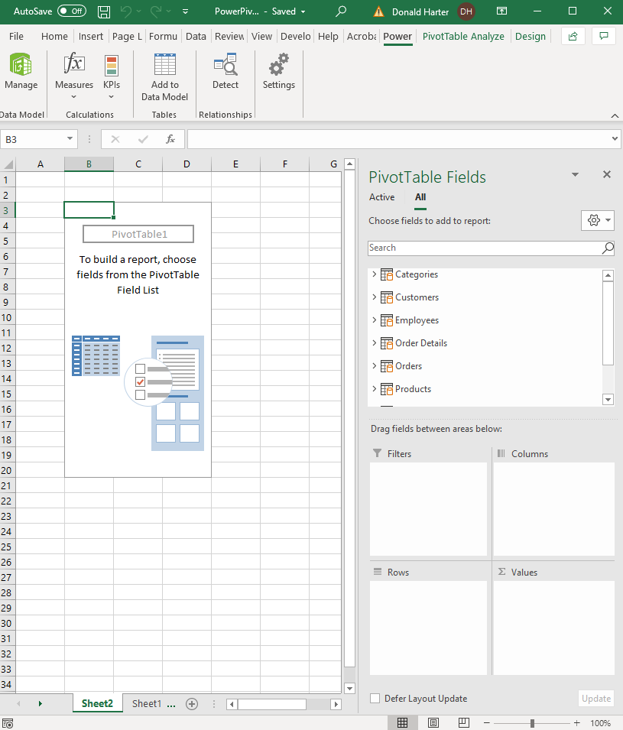

1. Notice that in the upper right of the pivot table, it lists PivotTable Fields. In this case, we now have all tables, not just one table.
2. Let us build a Pivot Table with the total quantity ordered for each category of products. Which table has CategoryName? Which table has Quantity (ordered)?
3. Click on the arrow next to the table Categories. Click on CategoryName and drag to Rows.
4. Scroll down in the PivotTable Fields until you see Order Details, then click on the arrow next to the table Order Details. Click on Quantity and drag it to Values.
5. You should see the view below.

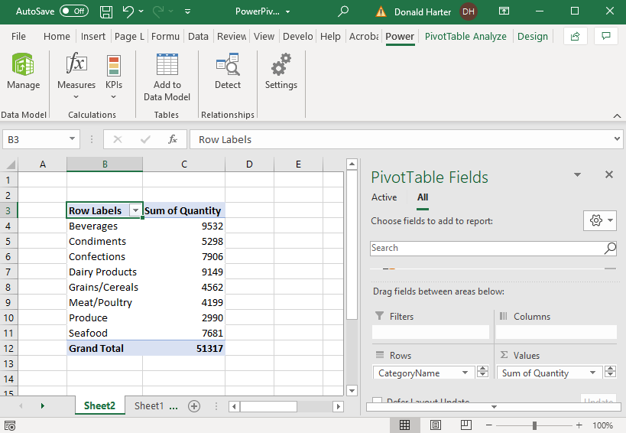

**5.9.2 PowerPivot Slicers Demo**

Let us dive deeper and examine quantity ordered by category and by a customer’s country. A Slicer allows you to select data in varying “slices.”

1. First, find where a customer’s country is stored. It is in the table Customers, in the field Country.
2. In the PivotTable screen, look for PivotTable Analyze in the upper right corner of the screen.
3. In the top middle of the screen, click on Insert Slicer.

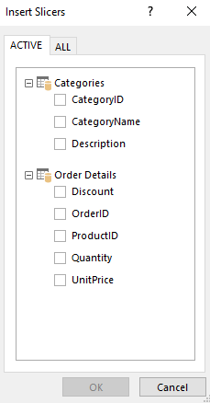

1. The Active tables are the ones we have used so far. But Country is stored in the Customers table. Click on ALL to see all tables, then check the box for Country in the Customers table. Click OK.

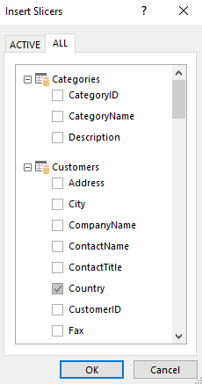

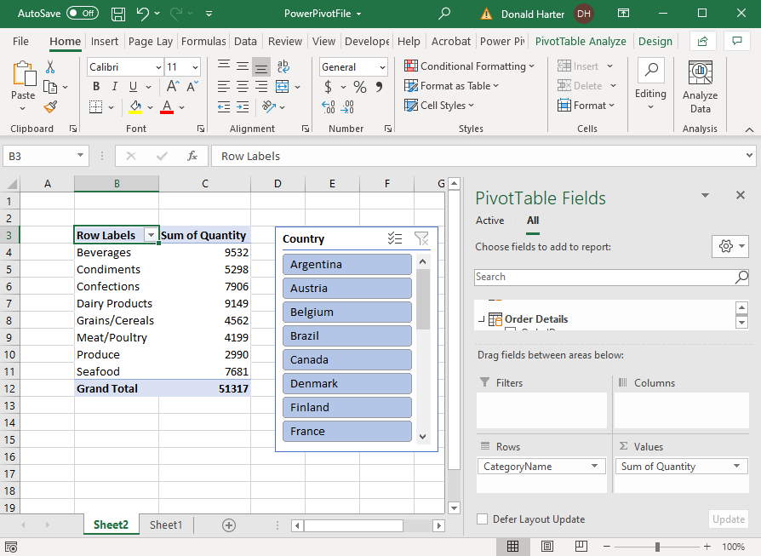

1. Notice that all countries are highlighted. Click on Argentina and watch how the numbers change.
2. To select more than one country, hold down the Control (Ctrl) key and select multiple countries. Select Argentina and Austria.
3. To return to the entire list, click on the funnel picture (filter picture) in the upper right corner of the slicer.
4. To remove the slicer, right click on the slicer and click on Remove “Country.”

**5.10.2 PowerPivot Timelines Demo**

A useful technique for filtering data by dates is the Timeline option.

1. First, click on the data to restore all options on the screen.
2. In the PivotTable Analyze tab, click on Insert Timeline.
3. Click on the All tab and check the box for OrderDate in the Orders table, then OK.

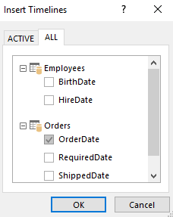

1. Notice that all dates are highlighted in blue. Click on January 1995 to highlight only that month.
2. You can select multiple months by holding down the shift key by clicking on multiple months. Highlight January and February 1995.

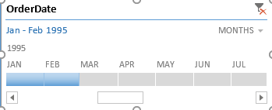

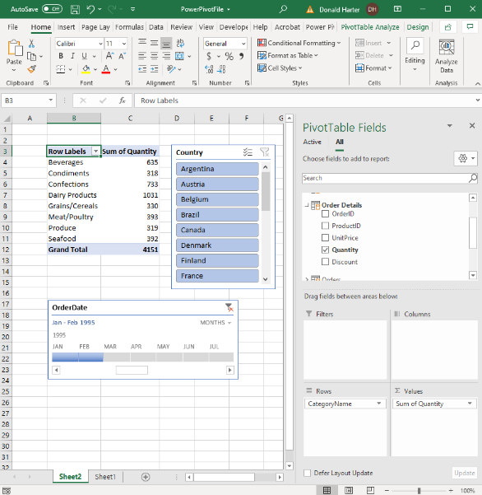

1. Click on the filter in the upper right corner of the Timeline screen to bring back all data.

**5.11.2 PowerPivot Charts Demo**

Pivot charts can also be created in Power Pivot.

1. Click on PivotTable Analyze.
2. Click on Field List to pop up the field list on the right side of the screen.
3. Click on the arrow next to Shippers, check the CompanyName box, and drag it to Columns.

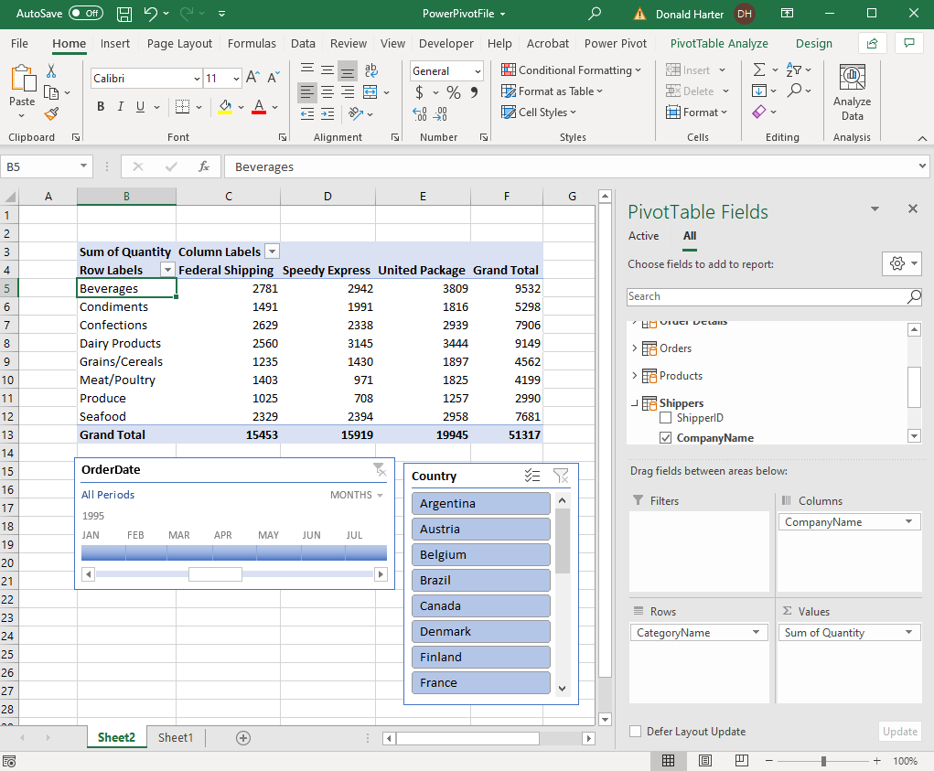

1. Next, click on PivotChart in the upper right corner of the screen.
2. Select my favorite, 3-D Column, then OK.

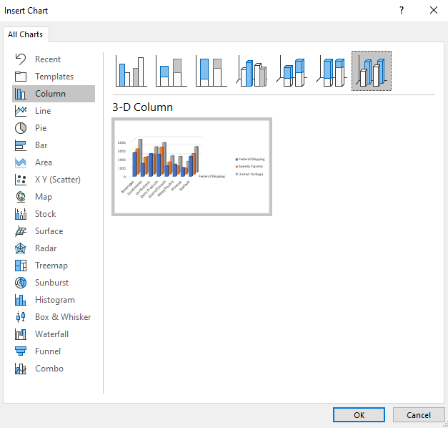

1. Arrange the Timeline, Slicer, and graph on the page.

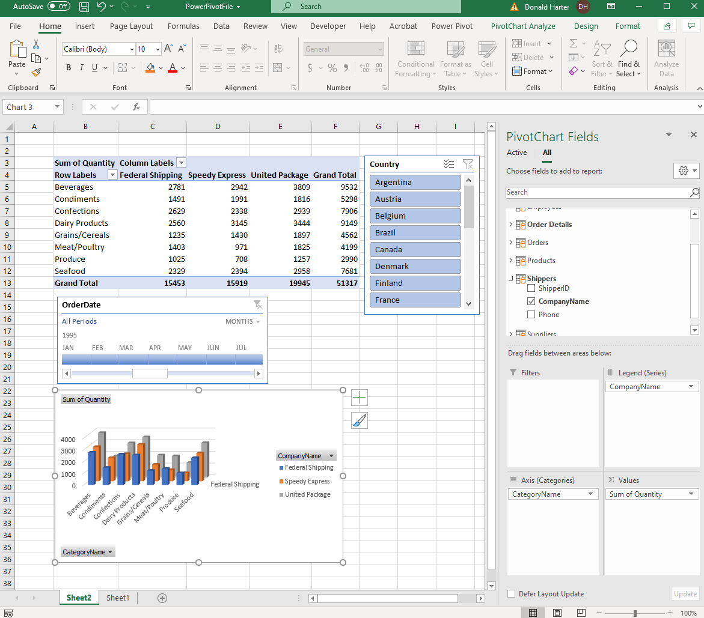

**5.12.1 PowerQuery/PowerPivot Website Example**

To connect to website data, there are some additional steps required. In this exercise, we will try to compare oil production and oil prices.

1. Open a new Excel spreadsheet.
2. Click on the Data tab, Get Data, From Other Sources, From Web.

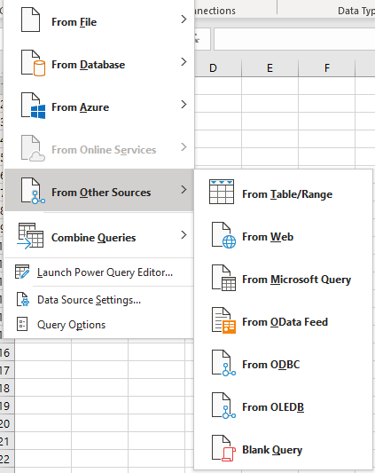

1. In the URL space, enter the following web address. This web page contains the oil production. Suggest that you copy the link below to Excel. Click OK.

https://www.eia.gov/opendata/qb.php?sdid=PET.MCRFPUS2.A

1. On the left side of the screen, click on Chart Data. Excel will automatically find the table and connect to it.

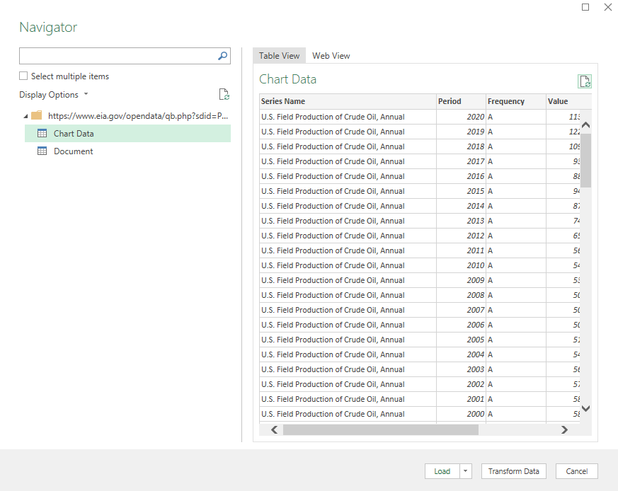

1. Above the table, change from Table View to Web View. This is the original view of the web page.

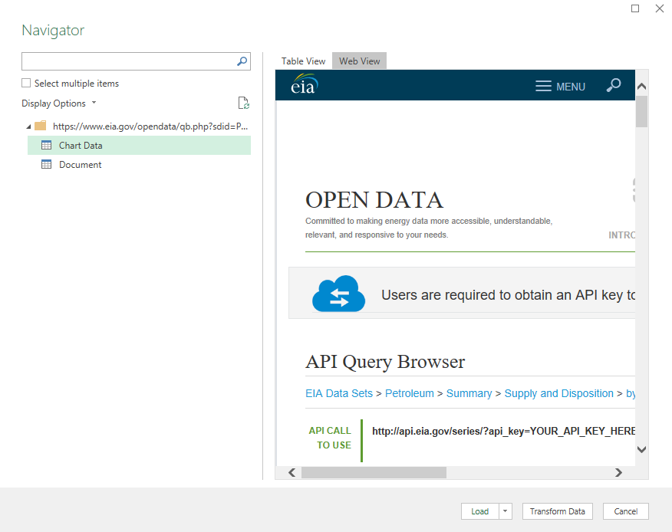

1. Click on Table View, then Load.

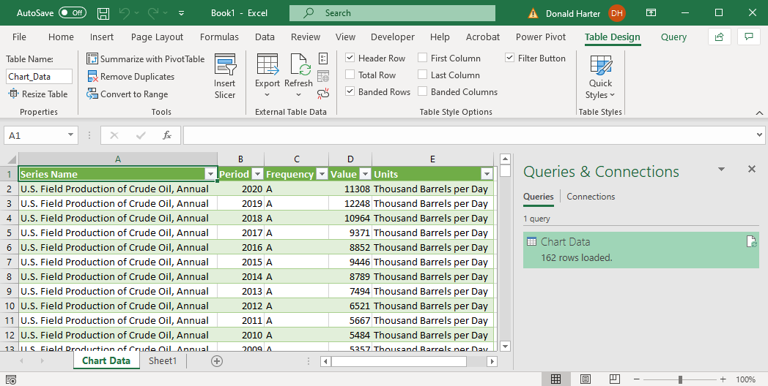

1. To edit the query name and column headings, click on the Query tab at the top, then Edit.
2. On the right side of the screen, under Properties, change Name from Chart Data to CrudeOilProduction.
3. Double click on the header Period, change it to Year.
4. Double click on the header Value, change it to ThousandBarrelsperDay.

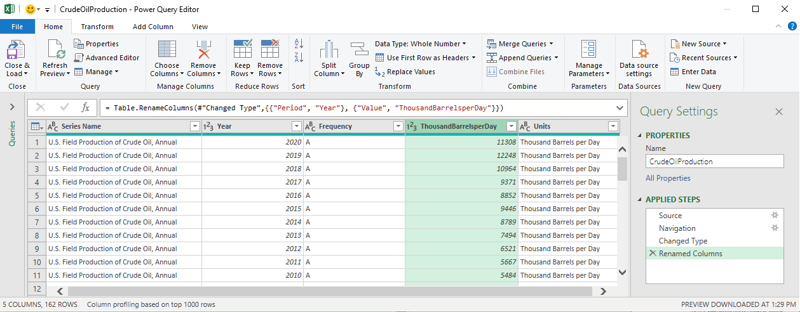

1. Click Close & Load to save the changes.

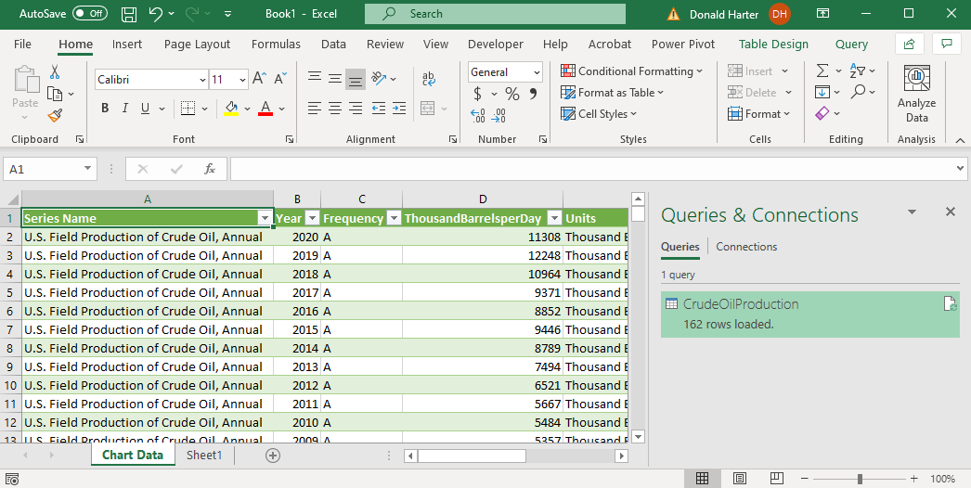

1. Next connect to the Price data.
2. Click on the Data tab, Get Data, From File, From Workbook.
3. Click on Week5-Data-CrudeOilPrices.xlsx, then Import.

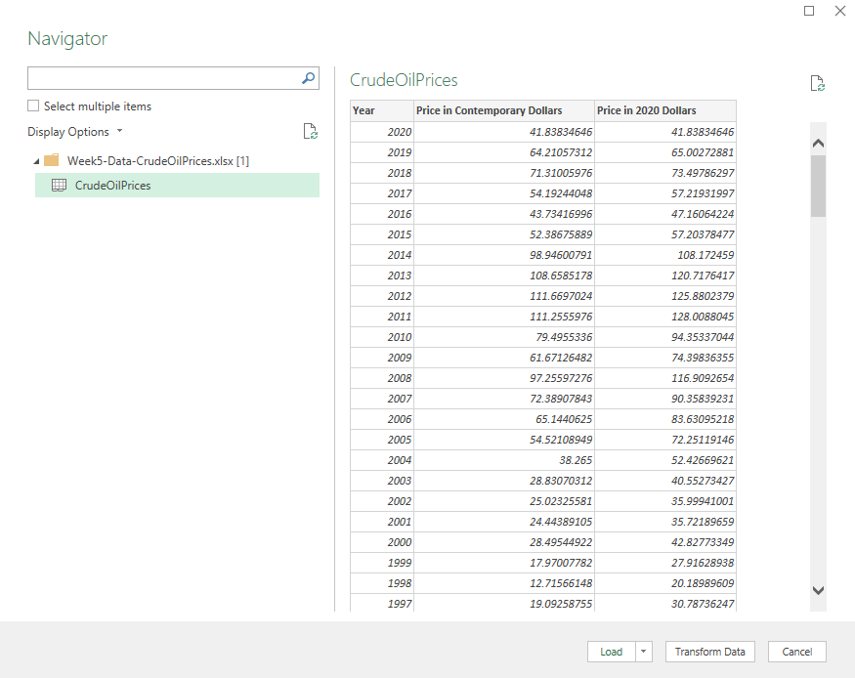

1. Click on CrudeOilPrices, then Load.

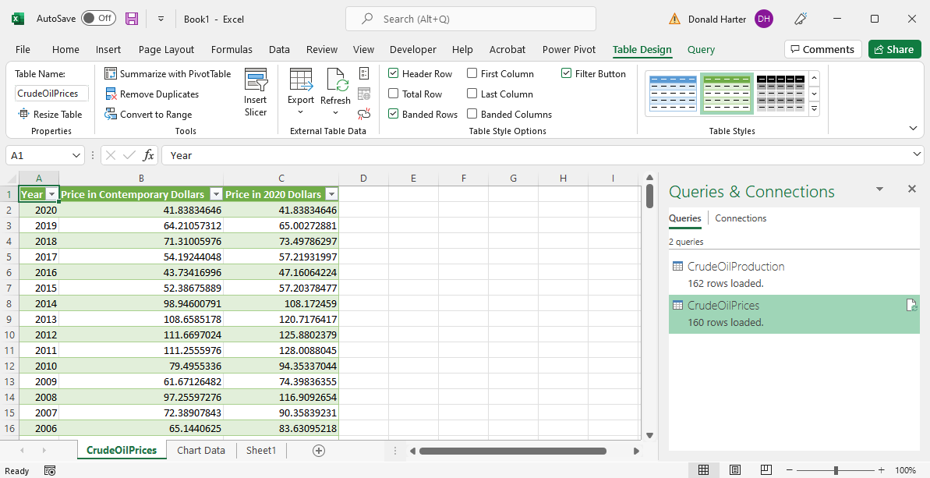

1. Click on PowerPivot at the top of the screen.
2. Click Add to Data Model.

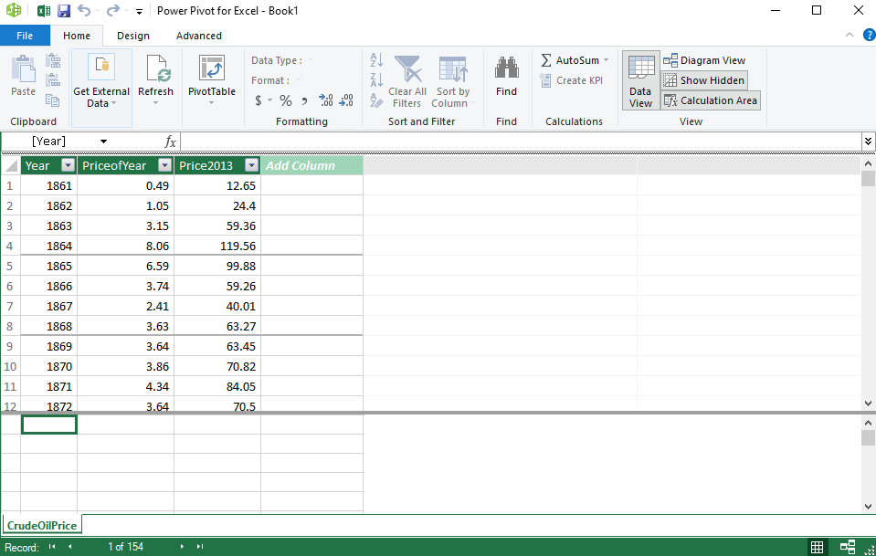

1. Go back to the main Excel screen, click on the CrudeOilProduction Query, then Add to Data Model.

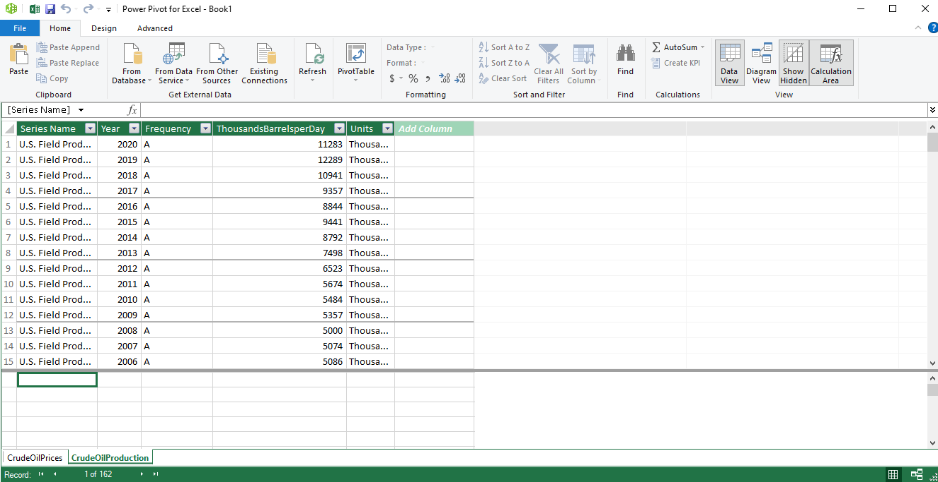

1. Click on Pivot Table, Pivot Table, then OK.

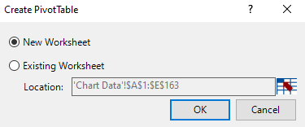

1. Click on the arrow next to CrudeOilProduction in the PivotTable Fields.
2. Drag Production: Year to Rows.
3. Drag Production: ThousandBarrelsperDay to Values.
4. Click on the arrow next to CrudeOilPrices
5. Drag Price in 2020 Dollars to Values.
6. Notice that Sum of Price in 2020 Dollars looks odd.
7. Notice the warning in yellow “Relationships between tables may be needed.

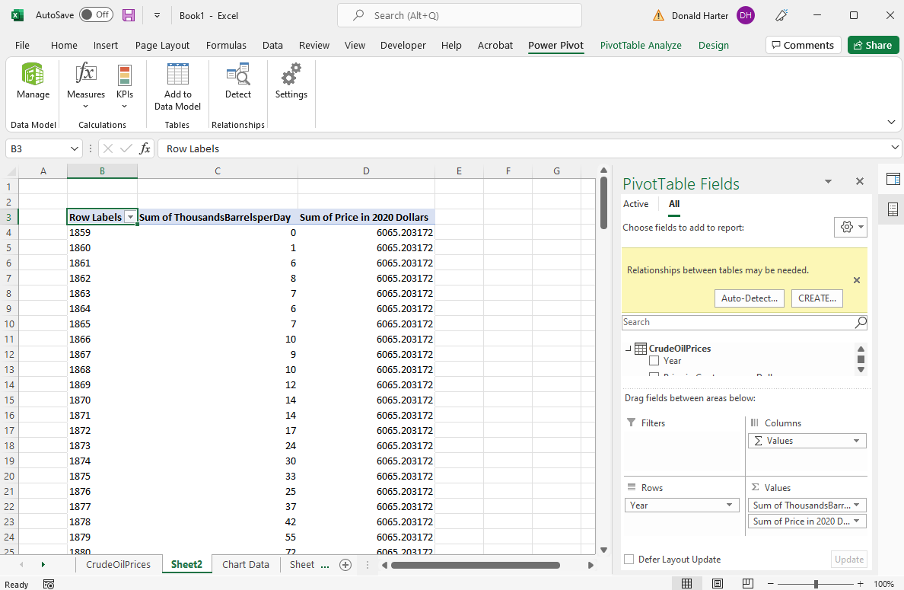

1. Click on Auto-Detect.
2. Excel attempted to fix the problem but could not.

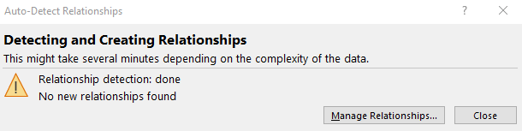

1. Next, assist Excel by clicking on Manage Relationships.

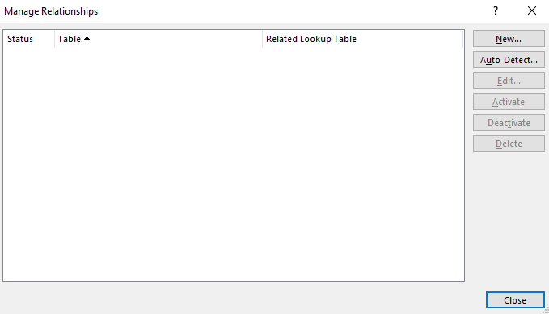

1. Click on New to create a new relationship.
2. For Table, click on CrudeOilPrices.
3. For Related Table, click on CrudeOilProduction.
4. For Column, click on Year.
5. For Related Column, click on Year.
6. Click OK.

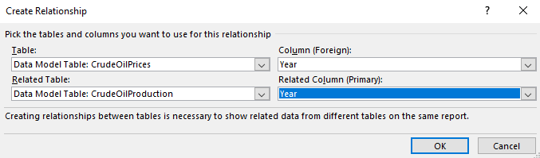

1. After the Manage Relationships screen reappears, click Close.
2. The Price in 2020 Dollars data now appears correct.

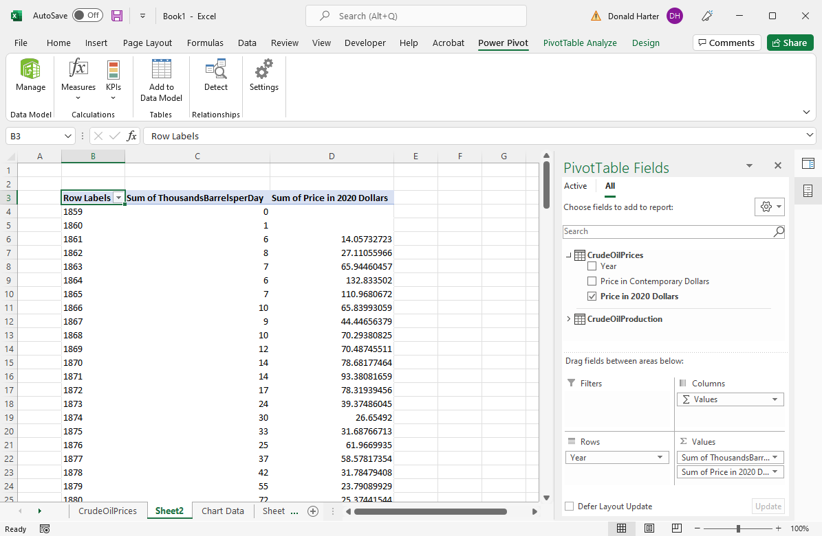

1. To create a PowerPivot chart, click on Pivot Table Analyze, Pivot Chart.
2. Select Combo chart at the bottom.
3. For Price2013, check the box for Secondary Axis.

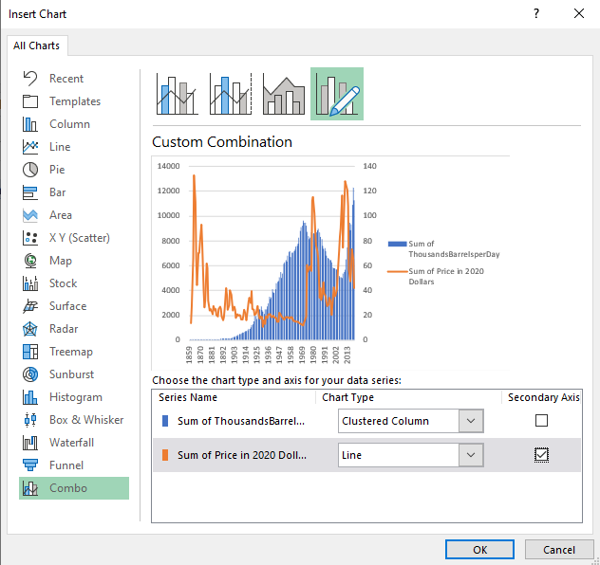

1. Click OK.

